ÇANKAYA UNIVERSITY – ECE DEPARTMENT – ECE 376
2015 Spring Term April 2015
Experiment 12: Construction of 8 PSK, probability of error curves based on Xilinx blocks.
Experiment constructed from Matlab Simulink Xilinx blocks is given on course webpage with the names PSK_Exp12_Pe.mdl” and “CorrMHTE.m”
- Download the model file and the m file from the course web page and start Matlab from “System Generator” icon. Open the model file, “PSK_Exp12_Pe.mdl”.
- This experiment is for the construction of probability of error (P_{e}) curve for 8 PSK modulator (transmitter) and demodulator (receiver), based on Xilinx blocks and the lecture notes “Dimensionality of Signals_ASK_PSK_QAM_FSK_Jan 2013_HTE”.
- As seen from Fig. 1, the model file is arranged in the form of subsystems shown in while colour. Apart from the error “Error Rate Counter” and the “Display”, these subsystems are named, “Transmitter”, “Receiver” and “Noise Generator”. By double clicking on the subsystem, it is possible to see the constituents.
- After double clicking “Noise Generator” subsystem, you will see, the blue colured “AWGN” block. By again double clicking on that block, on the “Basic” tab menu, there will appear “wgn(1,131072,-20.77)” across “Initial value vector”. The present setting of ,-20.77 corresponds to SNR of 13 dB after subtracting -4.77 dB (due to bit energy being 10*log10(1/3) = -4.77 dB) and -3 dB (due to the two sidedness of the noise spectral density) from -20.77.
- This way, running the “PSK_Exp12_Pe.mdl” file by incrementing -20.77 one by one down to -3.77, you will obtain in the first line of the “Display”, the probability of error values covering the SNR range of -4 to 13 dB. Write these values in an m file of Matlab and make the plot of P_{e} against bit SNR. Compare your curve with the Fig. 7.57 of Proakis 2002, which is pasted below as Fig. 2.
- Bear in mind that the “Display” will contain a residual error, as seen from the Scope output (Fig.3). This residual error will be important particularly at low “Simulation stop time” setting. To subtract its contribution from given in P_{e} the display, a facility is provided in “Noise Generator” subsystem. Thus to cancel the effet of residual noise, you should make a run with constant set to zero in “Noise Generator” subsystem and subtract this value from the shown when this constant is at unity.
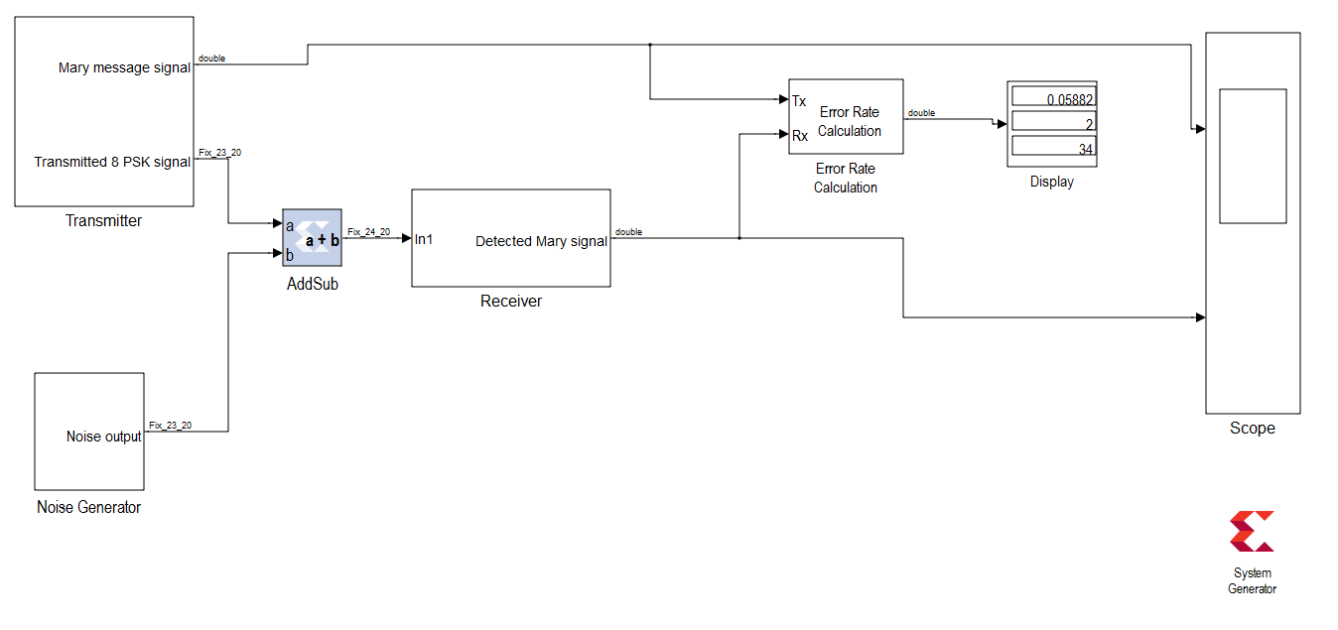
Fig.1 The model file “PSK_Exp12_Pe.mdl”.
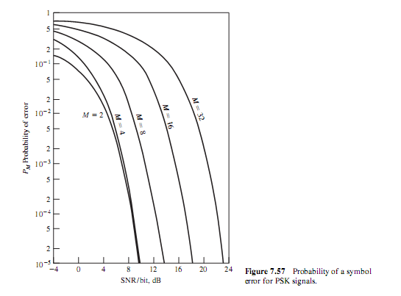
Fig.2 Probability of error curves in Fig. 7.57 of Proakis 2002.
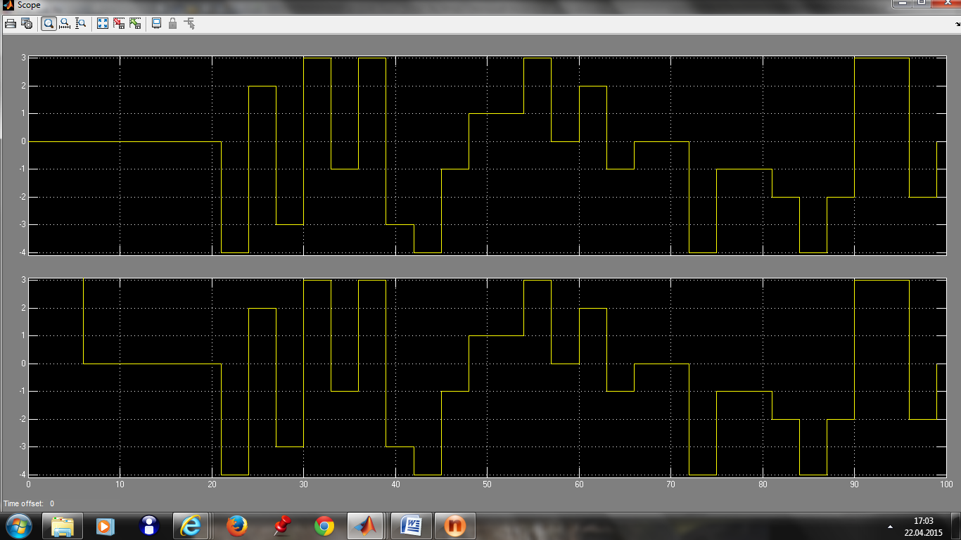
Fig.3 The scope output illustrating the residual error at the beginning of run.

