**ÇANKAYA UNIVERSITY – ECE DEPARTMENT – ECE 376**

**2015 Spring Term April 2015**

**Experiment 11:** 8-PSKTransceiver (Transmitter and Receiver) Design for Virtex-5 FPGA Board

**Experiment coded in MATLAB is given on course webpage with the names “PSKMary_Exp11.mdl” and “CorrMHTE.m”**

1. Download the model file and the m file from the course web page and start MATLAB from “System Generator” icon. Open the model file, **“PSKMary_Exp11.mdl”.**
2. This experiment is the construction of 8 PSK modulator (transmitter) and demodulator (receiver), based on Xilinx blocks and the lecture notes “**Dimensionality of Signals_ASK_PSK_QAM_FSK_Jan 2013_HTE”**.
3. The ordering of 8 PSK signal vectors and their Mary assignments are shown in Fig. 1. This constellation diagram is constructed, using (3.6) in the lecture notes, entitled, “**Dimensionality of Signals_ASK_PSK_QAM_FSK_Jan 2013_HTE.pdf**”
4. After pressing the “**Start simulation**”, button in the model file, **“PSKMary_Exp11.mdl”,** observe that waveforms similar to the one will appear on on the scope screen.
5. Examine the the file **“CorrMHTE.m”,** which is used to make correlation metric evaluations and detection in a manner similar to(6.25) and (6.26) of “**Dimensionality of Signals_ASK_PSK_QAM_FSK_Jan 2013_HTE**”, Write comments to the functionality of each line.
6. You may change the “**Number of bits**” and “**Feedback polynomial**” in menu of LFSR to generate a different message signal, using the one of the generator polynomials given in the file, “**LFSR_Genpoly_16042015**”. Observe the consequent changes.

Fig.1 Constellation diagram and assignment of Mary levels to signal vectors in the experiment.

Considering (3.6) from the lecture notes “**Dimensionality of Signals_ASK_PSK_QAM_FSK_Jan 2013_HTE.pdf**” , signal vectors are calculated and placed on the constellation diagram which is shown in Fig.1.

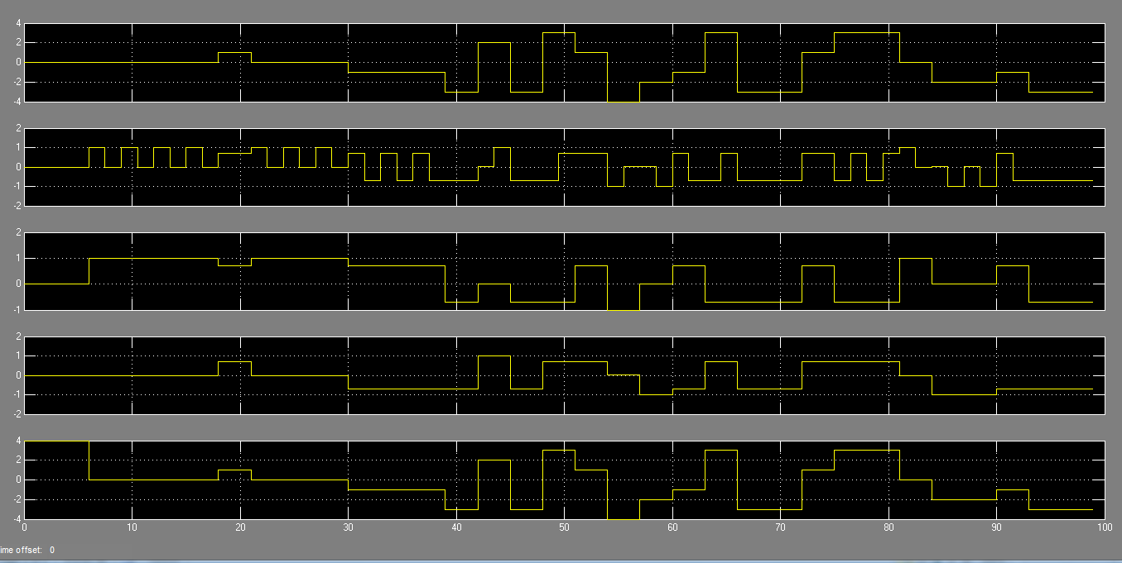

Fig.2 Typical signal waveform output from the scope.

Check that you obtain the same signal waveform output as that displayed in Fig. 2. In this output, the fist channel is the Mary message signal, the second channel is the 8 PSK representation of the Mary signals in accordance with the constellation diagram of Fig. 1. You are expected to name and make interpretations about the rest of the waveforms on channels three, four and five. You are also expected to explain the role of each block given in Fig. 3, which is the copy of **PSKMary_Exp11.mdl**.



Fig.3 8-PSKTransceiver (Transmitter and Receiver) Design for Virtex-5 FPGA Board